013 TypeScript - optional parameters

TypeScript Kata List – Blog Page

[TypeScript Kata List on GitHub](https://github.com/robertdunaway/katas-typescript)

# Duration

10 minutes

# Brief

Using required, optional, and default parameters. Also an example of interpolation.

### For More Information

BING/GOOGLE: “TypeScript optional default parameters interpolation”

# Instructions

Get tutorial folder or the entire katas-typescript repo.

Open the [before/*.sln] file and execute the kata.

Feel free to execute this kata multiple times because repetition creates motor memory.

# Github

* Before (start kata with this)
  + https://github.com/robertdunaway/katas-typescript/tree/master/013%20TypeScript%20-%20optional%20parameters/before
* After
  + https://github.com/robertdunaway/katas-typescript/tree/master/013%20TypeScript%20-%20optional%20parameters/after

# Kata

Create a function that accepts several required parameters and outputs an interpolated string to the console.

[highlight below for one possible answer]

// Create a function that accepts several parameters.

// These parameters are required by default.

var profile = function (fName: string, lName: string, age?: number

, height?: number, weight?: number): string {

// String interpolation

console.log(`name: ${fName} ${lName} age: ${age} height: ${height} weight: ${weight}`);

return '';

}

console.log('all parameters are required');

profile('John', 'Smith', 35, 180, 165);

Create a function with a couple required parameters and a few optional parameters.

[highlight below for one possible answer]

// Create a function where only fName and lName are required and the rest

// are optional.

var profileWithOptions = function (fName: string, lName: string, age?: number

, height?: number, weight?: number): string {

// String interpolation

console.log(`name: ${fName} ${lName} age: ${age} height: ${height} weight: ${weight}`);

return '';

}

console.log('example of optional parameters');

profileWithOptions('John', 'Smith');

Create a function with a couple required parameters and a few default parameters.

[highlight below for one possible answer]

// Create function with default parameters.

var profileWithDefaults = function (fName: string, lName: string, age: number = 18

, height: number = 150, weight: number = 100): string {

// String interpolation

console.log(`name: ${fName} ${lName} age: ${age} height: ${height} weight: ${weight}`);

return '';

}

console.log('example of default parameters');

profileWithDefaults('John', 'Smith');

profile('John', 'Smith', 35, 180, 165);

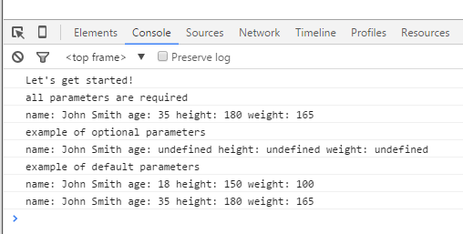

# Next

Take a few minutes and imagine more examples.